MACH4METAL

metalworking machinery
Transito 21
6909 DA BABBERICH Netherlands
Tel. +31 (0)316-247123
Fax: +31 (0)316-247956
info@mach4metal.com
www.mach4metal.com

Bank No : 66.52.13.883
IBAN : NL33 INGB 0665 2138 83
BIC : INGBNL2A

DAHLIH VMC 720 Machining

- Make : DAHLIH
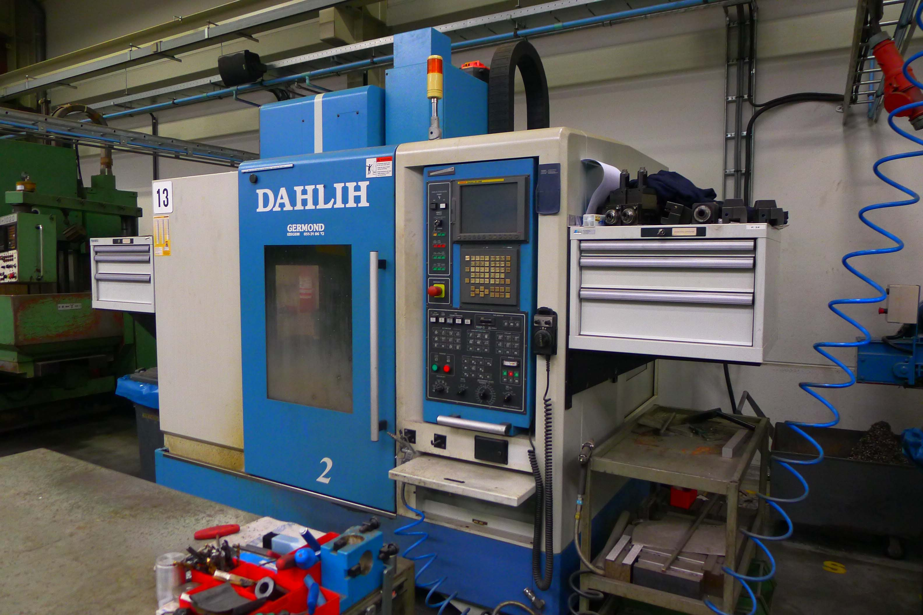
- Typ : Mcv 720
- No. :
- Age : 2007

- Capacity – Travel
- X - Travel : 720
- Y - Travel : 460
- Z - Travel : 510
- Spil – Table : 150 - 660

- Table dimensions:
- Length : 950
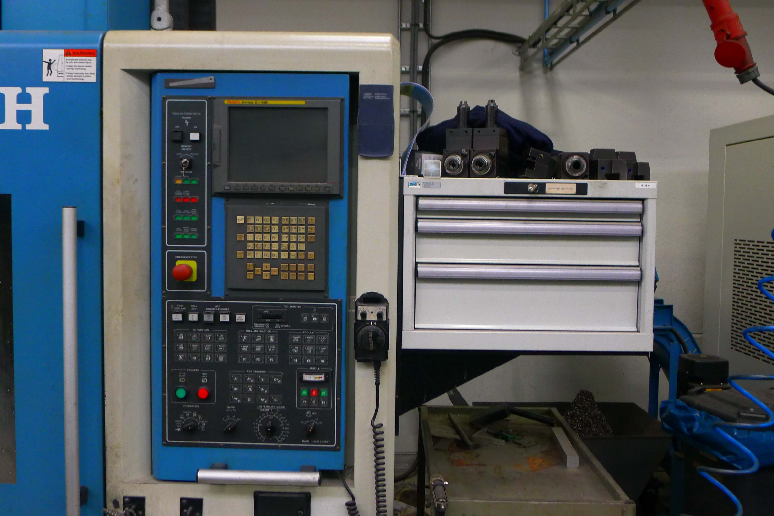
- Width : 560
- Load : 500 Kg

- Feeds X/Y/Z: 10.000 mm/min.
- Rapid : 30/30/20M/min

- Spindle : BT 40
- Speeds : 8.000 Rpm

- Dimensions:
- Length : 3.200
- Width : 3.700
- Height : 2675
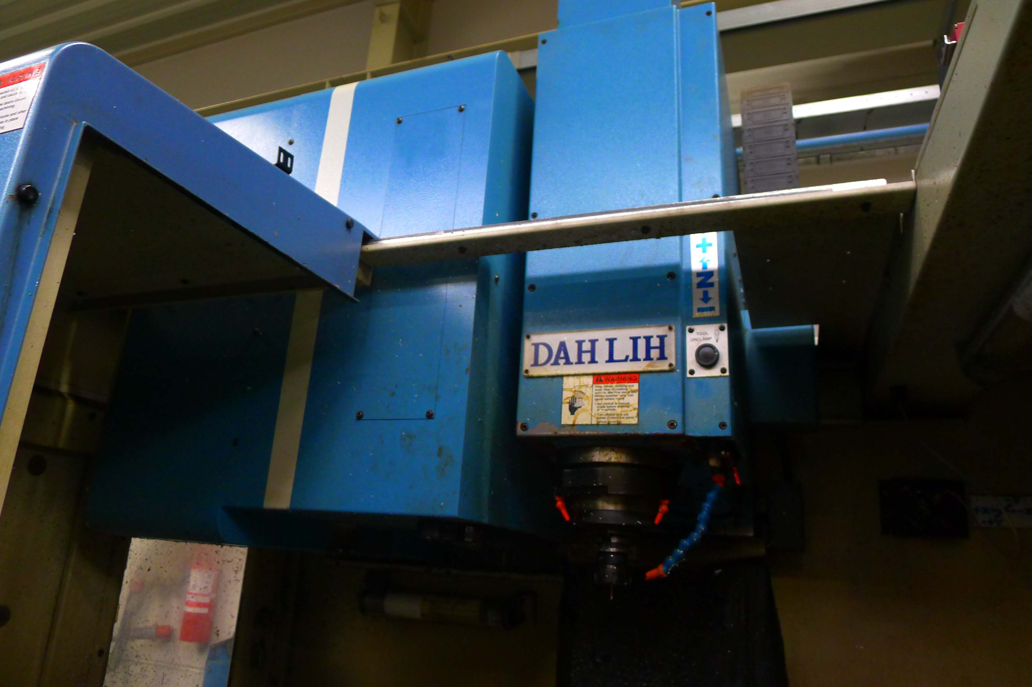
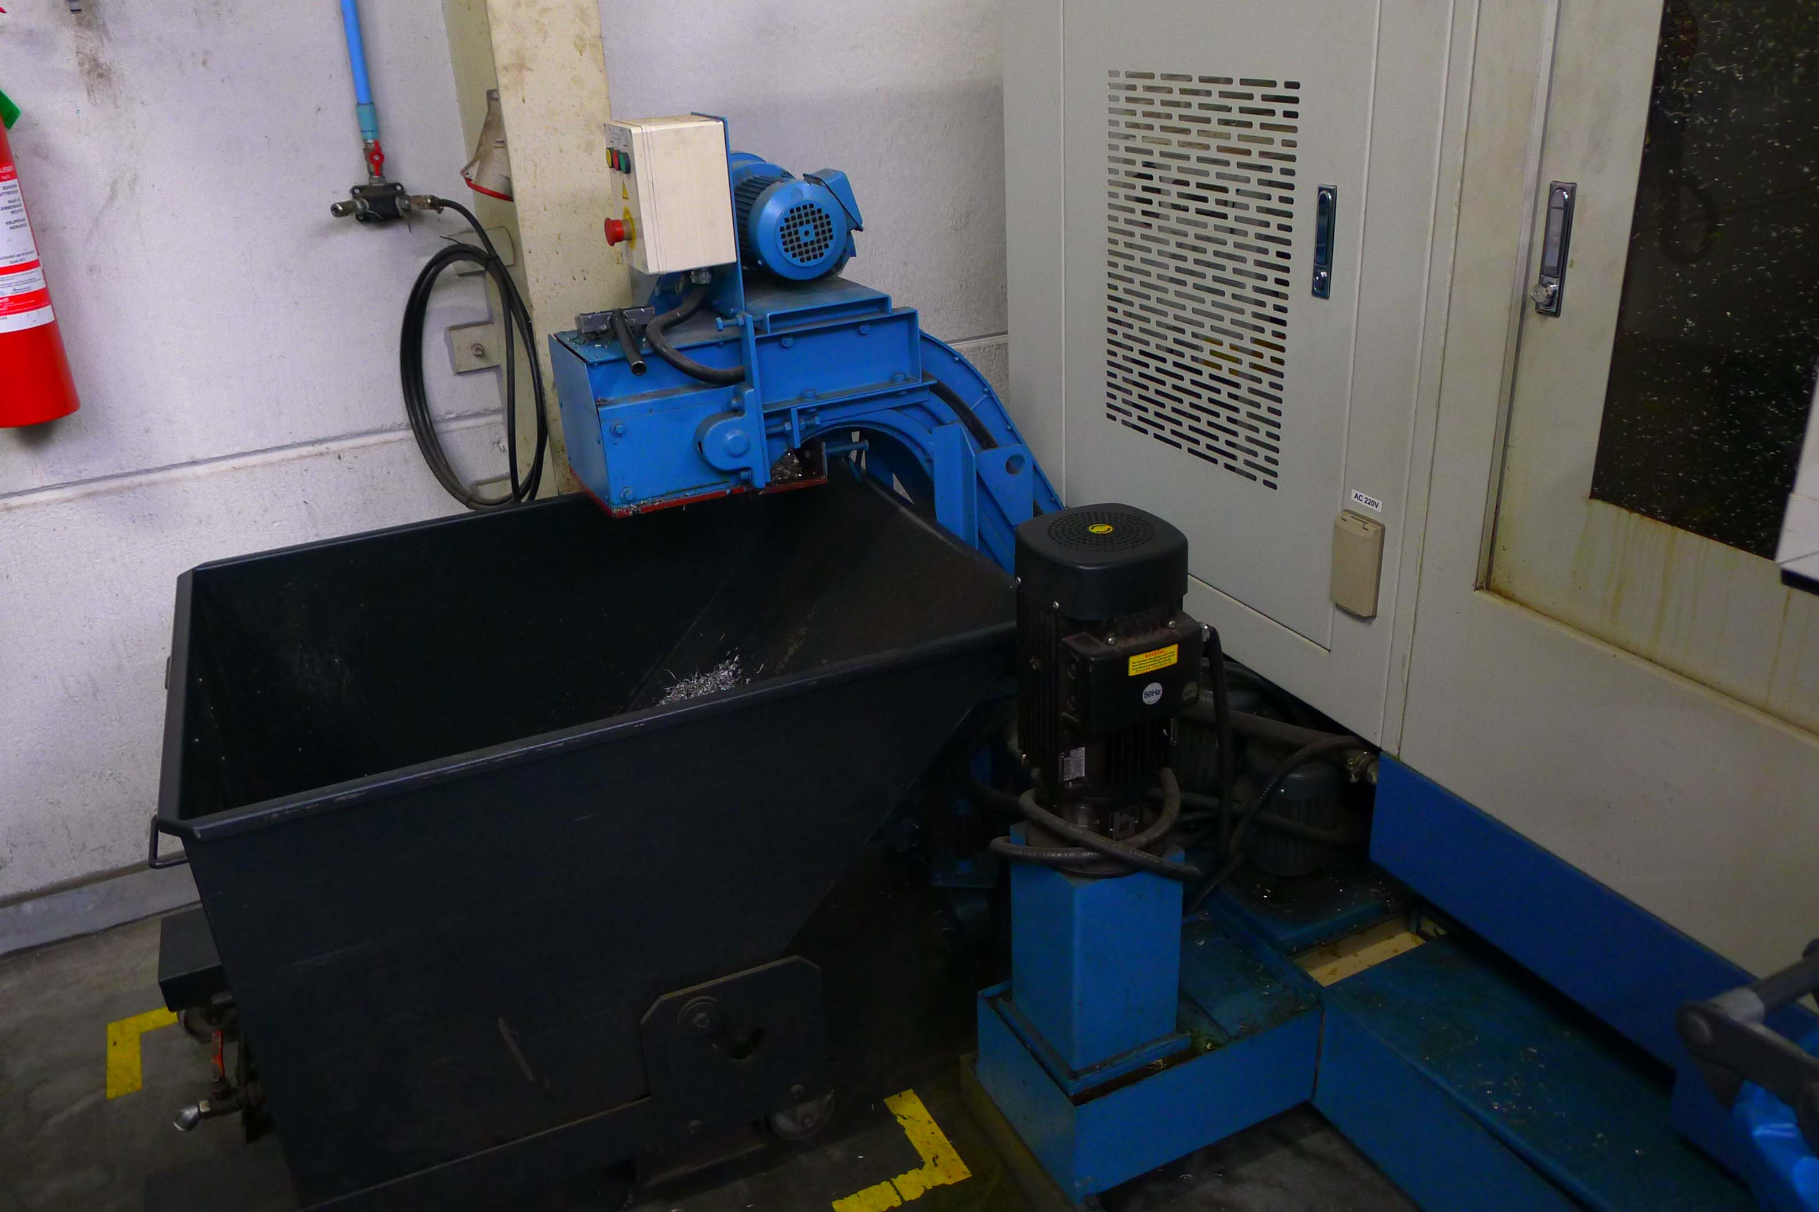
- Weight : 4.400 Kg

- Fanuc 21 iMB
- 20 Bar coolant
- Chip conveyor
- ATC 24 positions

Please Note: The above information has been obtained to the best of our ability and belief from, and from the manufacturers where possible. It is given in good faith, but its accuracy can not be guaranteed. Accordingly, it will not form a representation or constitute contractual terms. We advise you to check any vital details!

